# Module 4 Main Assignment

Baked some textures for the Barrel model that did not turn out so well in Unity.

I made prefabs of the models I have been able to import to unity.

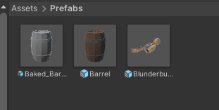

There is a problem with the metallic map applying to the whole object in unity instead of only the metal parts as it does in blender. I don’t know what causes the issue for now.

The textures are also bleeding on top of each other in Unity that is also not present on blender side. This is most likely due to how my object is UV unwrapped.

Here is the Barrel in blender with the same textures applied to it.

This is the texture node setup in blender.

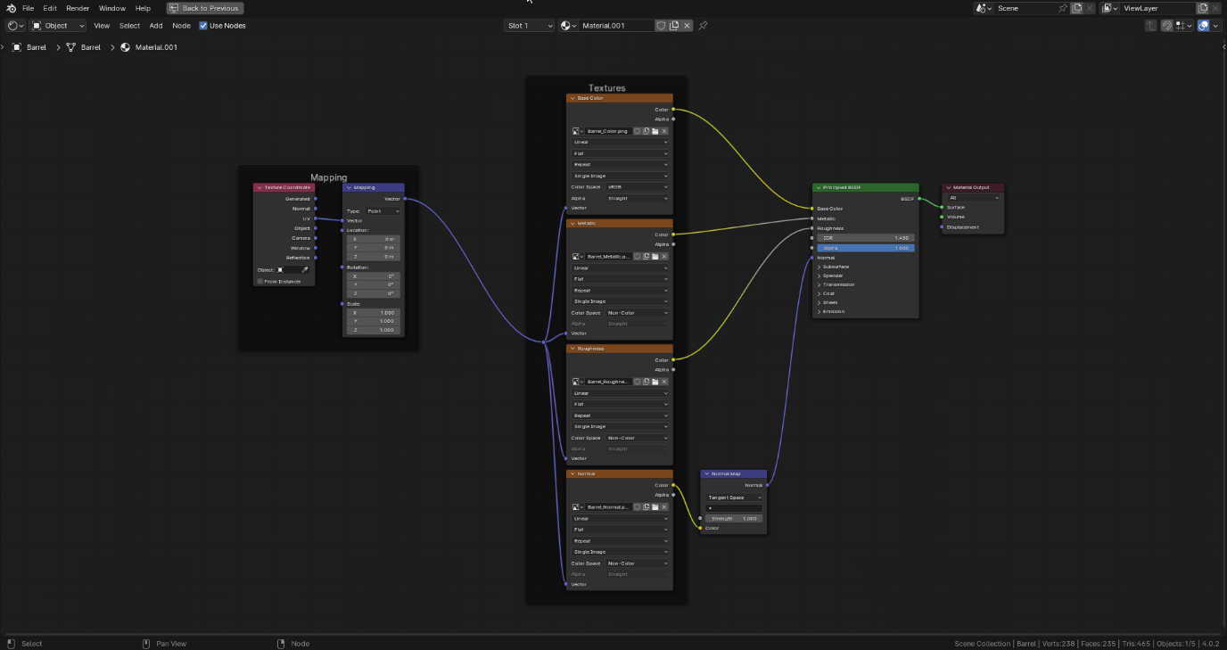

Onwards! One confusing tutorial at a time.